Lab Practical #04:
Installation of Network Simulator (Packet Tracer) and Implement different LAN topologies.
Practical Assignment #04:
- Create a simple network with switch and two or more pc. Also check connectivity between them using ping command or PDU utility.

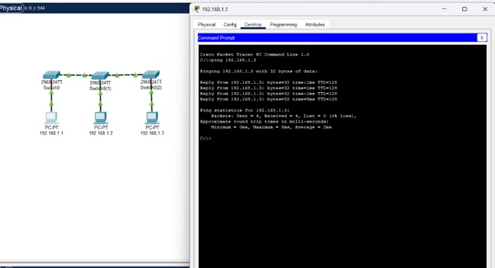

- Implement different topologies in packet tracer.
  - Bus
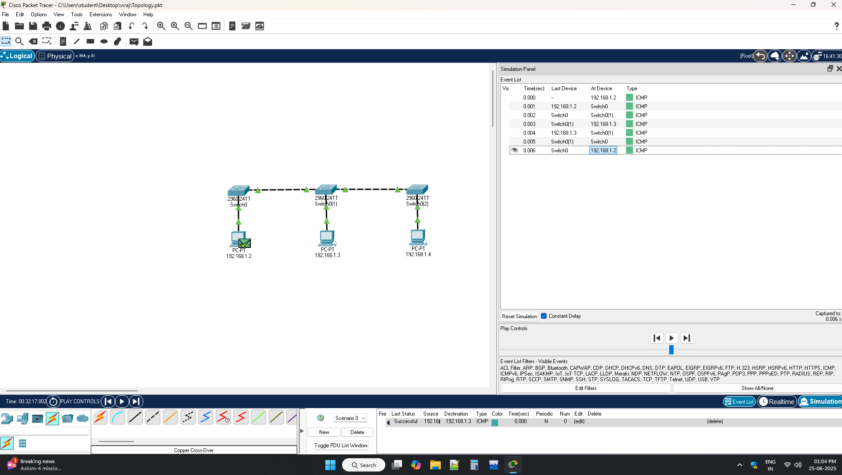

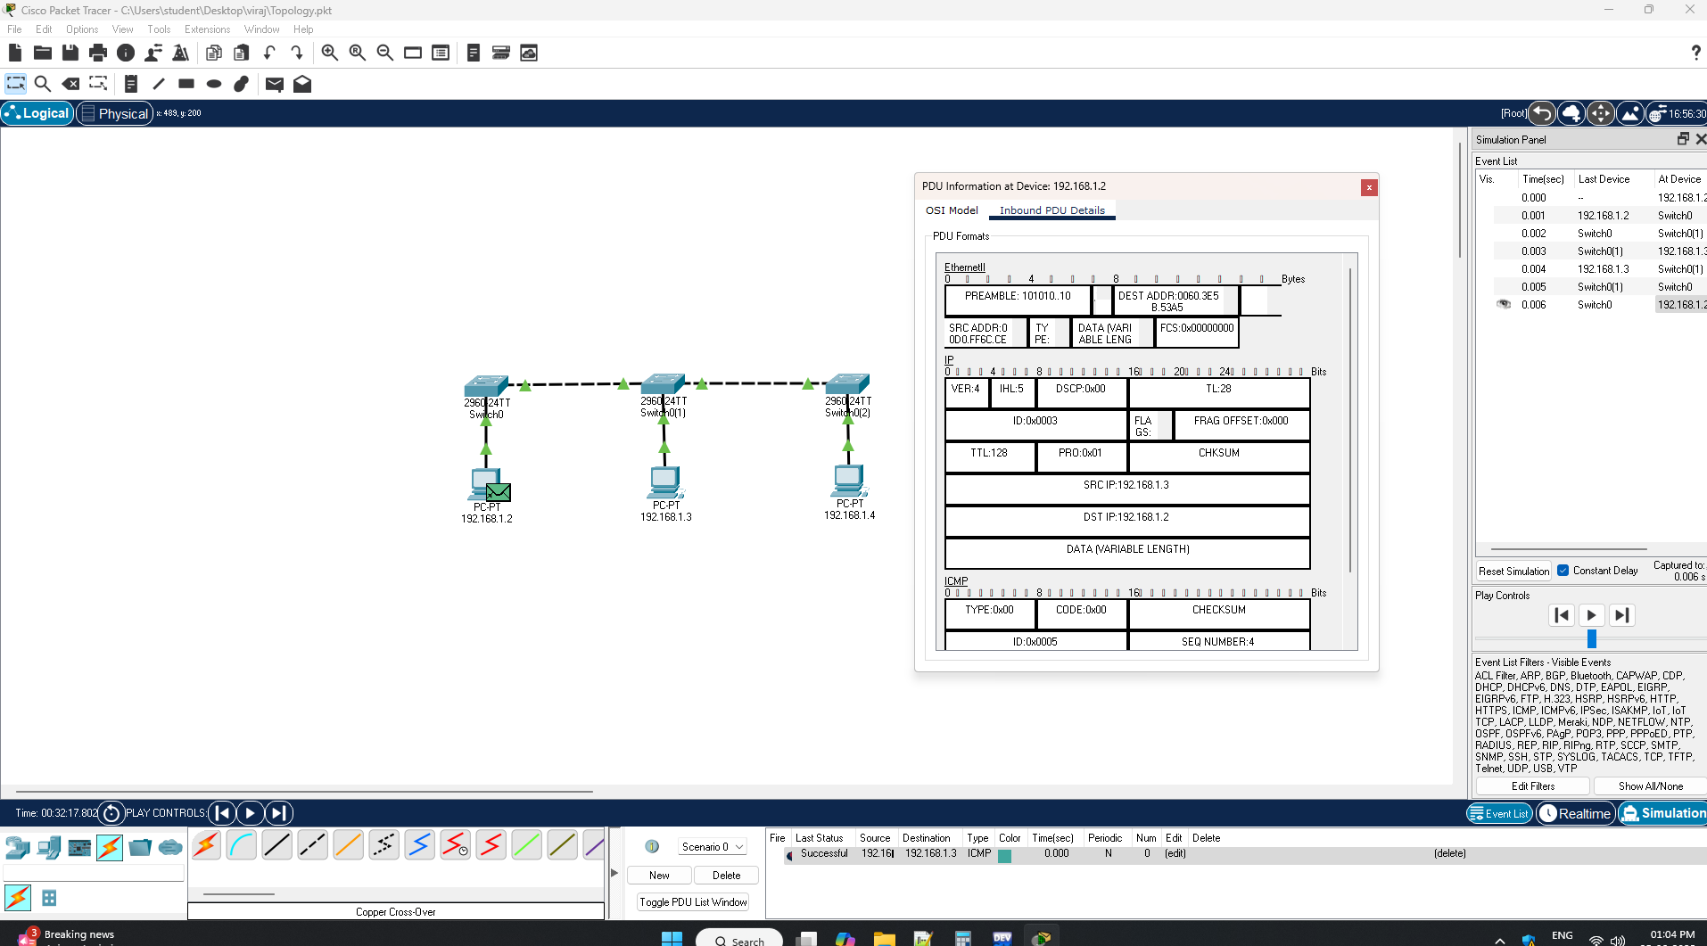

  - Ring

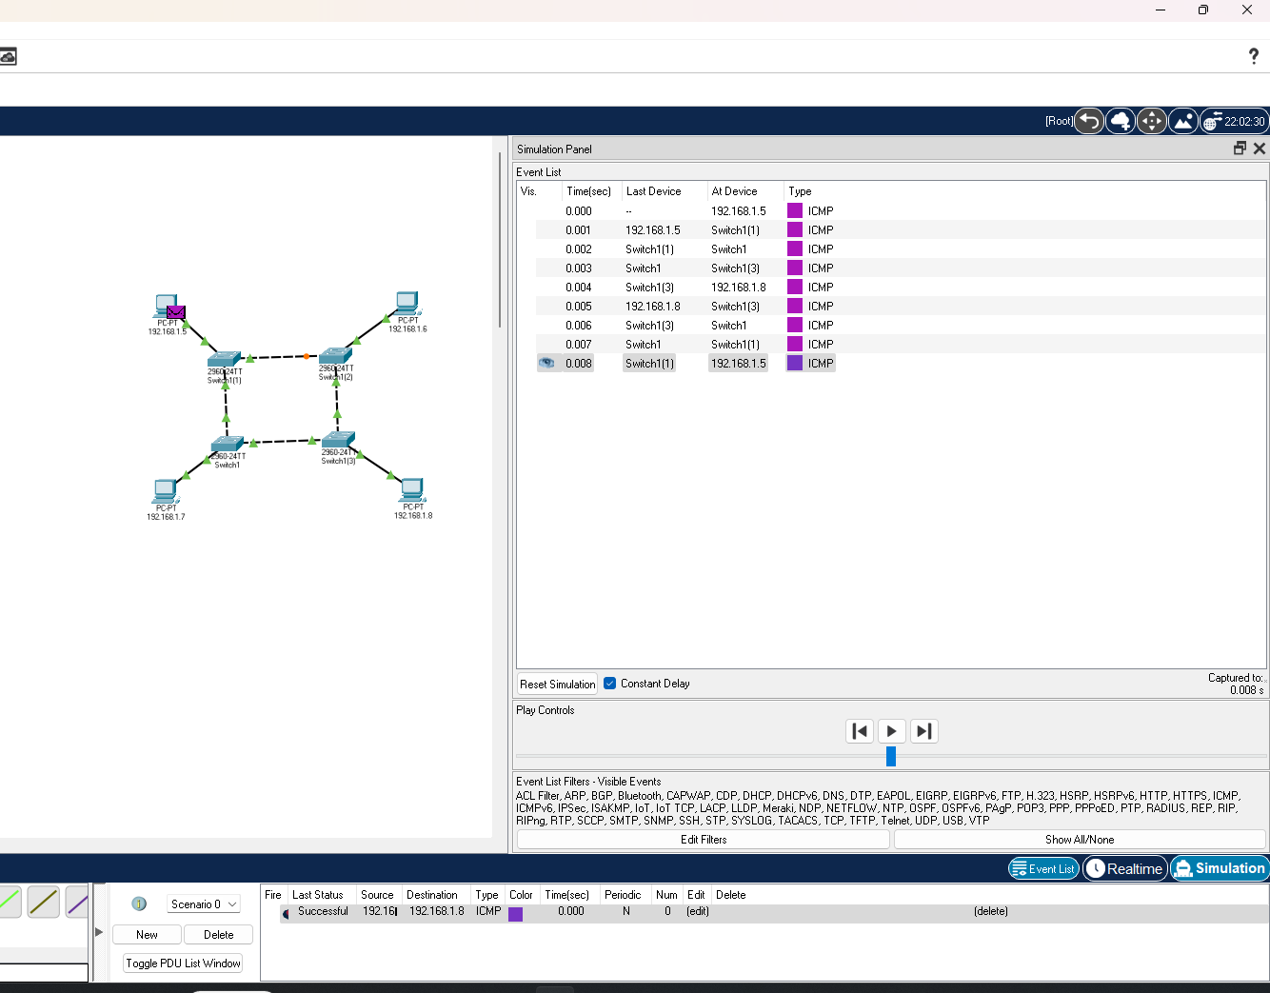

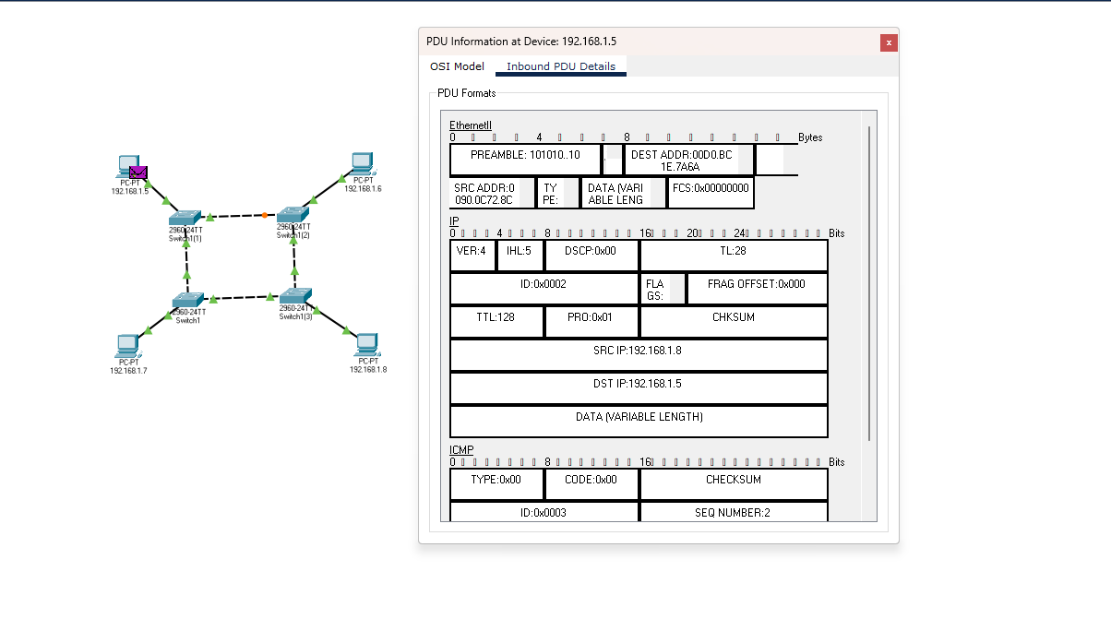

  - Star

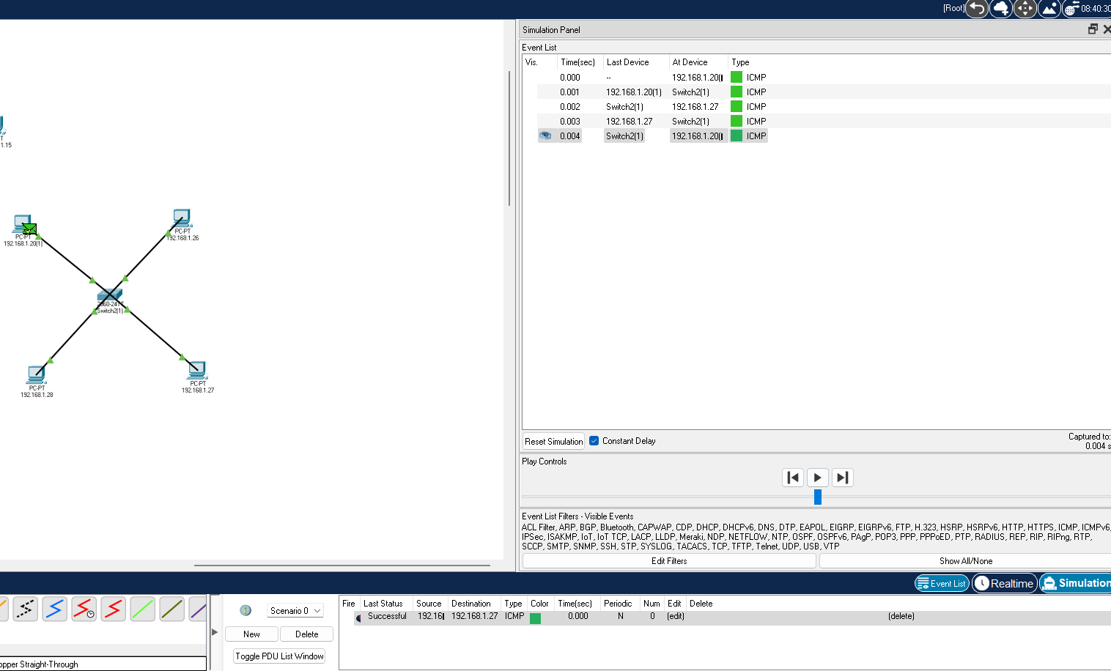

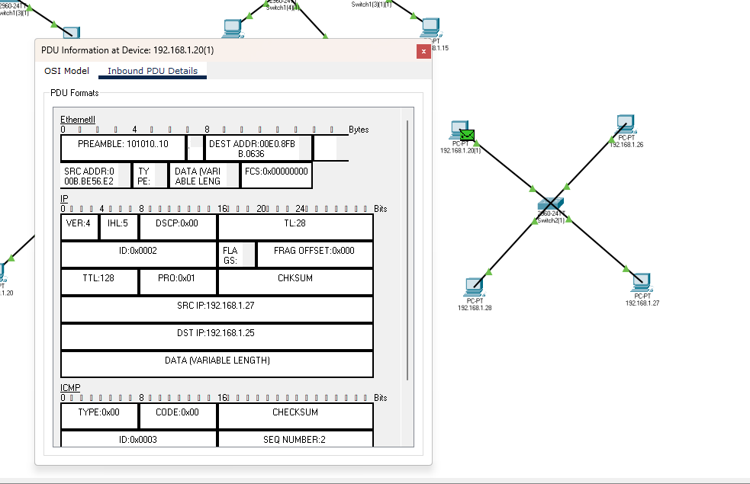
  - Mesh

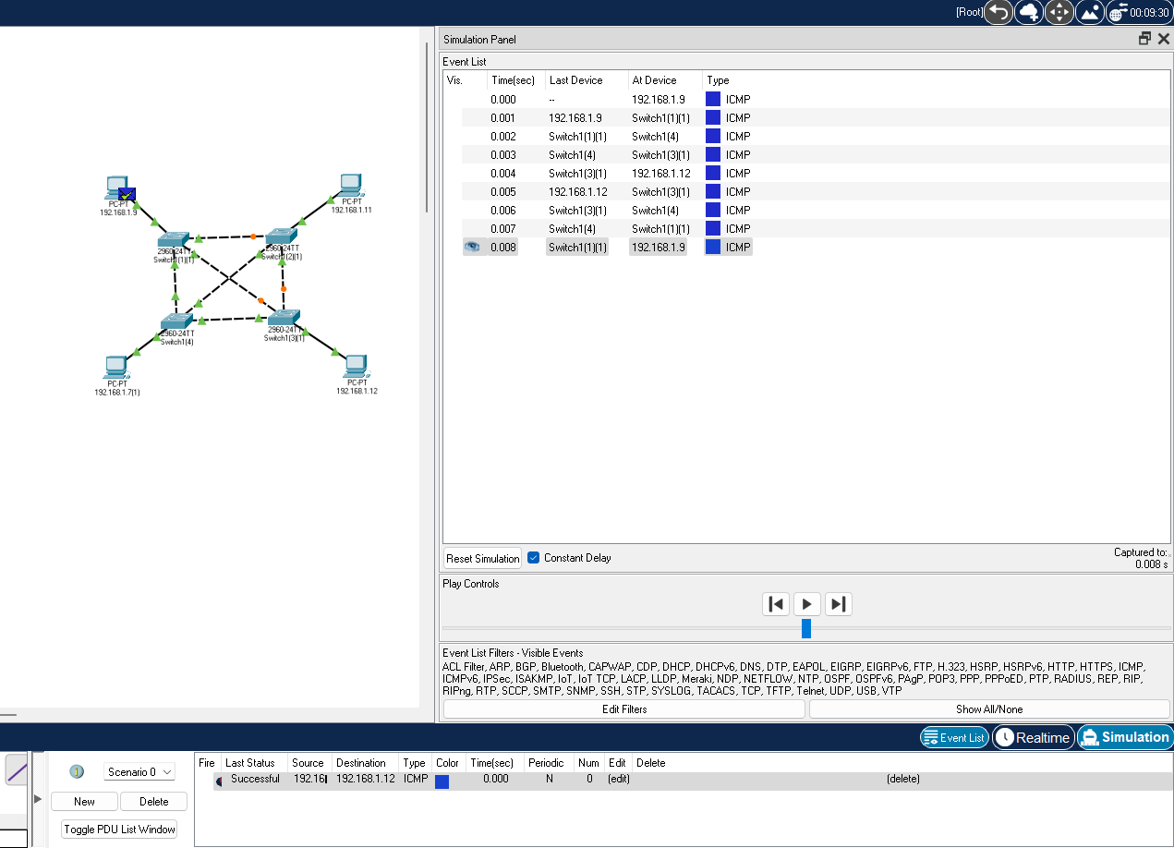

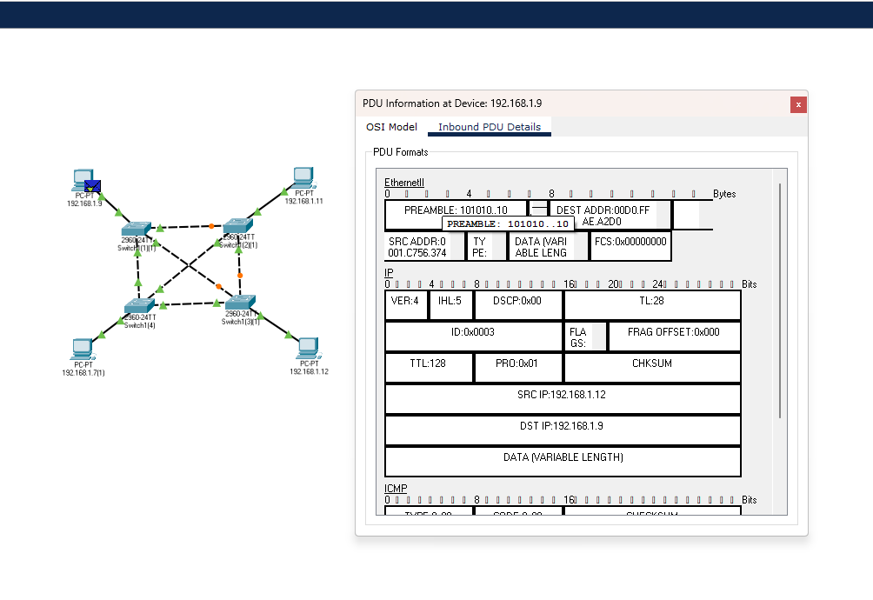

  - Tree
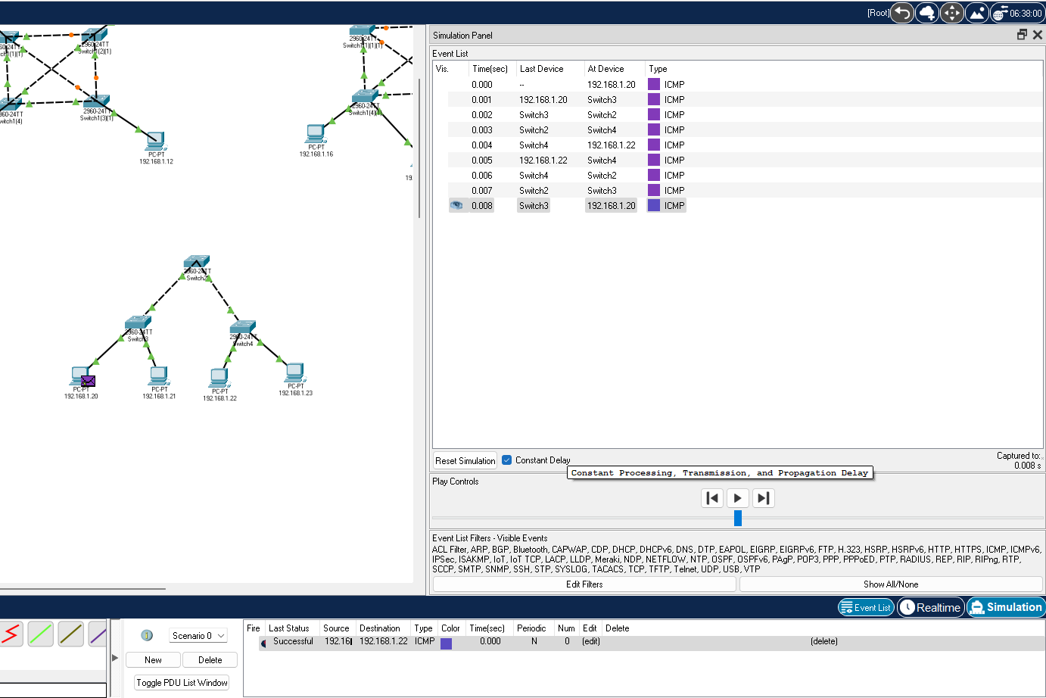

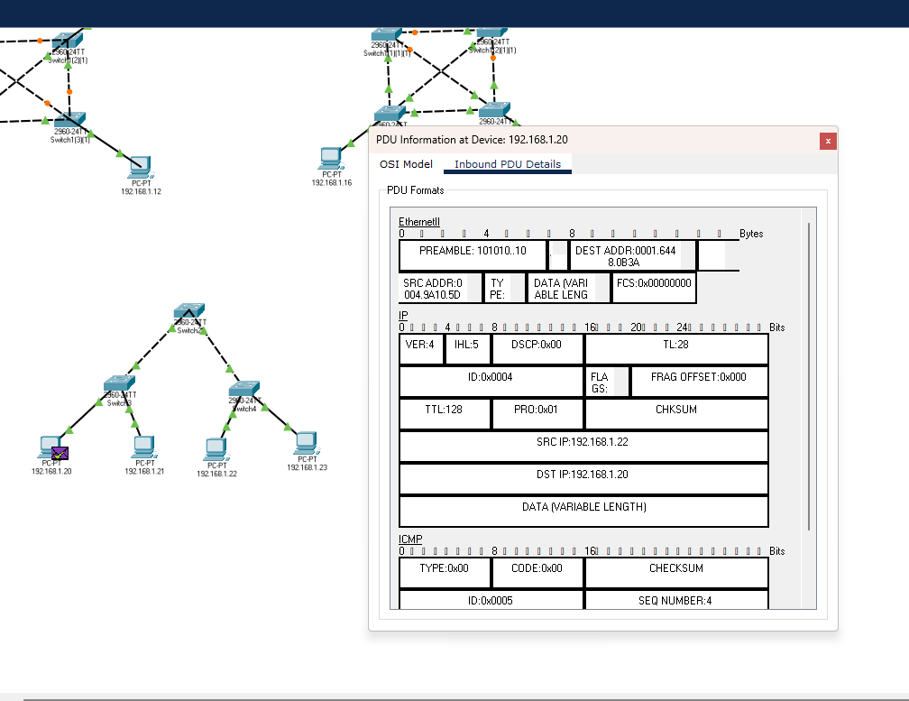
Instructions:
- Topology-wise Screenshot.
- Mention IP address of each pc as label.
- Ping command or PDU screenshot between two pcs.

